

NASTP Institute of Information Technology
Department of Computer Science
Semester Project Report
“Anemia Classification and Prediction Using Ensemble Machine Learning”

Field | Details
Submitted by | Ali Zeb (F2024CS029)  Saha Fahad (F2024CS026)  Saman Imran (F2024CS018)  Maryam Nauman (TF2024CS054)
Submitted to | Dr. Shahan Yamin Siddiqui
Semester | IV
Section | BSCS Fall 2024
Subject | Machine Learning (AI233)

1. Executive Summary
This report presents a comprehensive analysis of an anemia prediction system developed using machine learning techniques on a large-scale clinical dataset. The system leverages hematological blood parameters to classify patients as anemic or non-anemic, providing a decision-support tool for clinical settings.
The project encompasses exploratory data analysis (EDA), feature engineering, model training, and a real-time interactive prediction application. Two ensemble learning algorithms — Random Forest and XGBoost — were trained and evaluated, with the Random Forest classifier emerging as the best-performing model.
Dataset Size | Best Model | Accuracy | AUC Score
153,728 records | Random Forest | 93.48% | ~0.98
Key findings from this project include identification of Hemoglobin, Hematocrit, and RBC count as the most predictive features for anemia detection, and an ensemble voting approach that combines both models for robust predictions.

2. Introduction

2.1 Background
Anemia is a global health condition characterized by a deficiency of red blood cells or hemoglobin in the blood, resulting in reduced oxygen-carrying capacity. According to the World Health Organization (WHO), anemia affects approximately 1.62 billion people worldwide, representing nearly 24.8% of the global population. It is particularly prevalent among children under five, pregnant women, and elderly individuals.
Early and accurate detection of anemia is critical for timely clinical intervention. Traditional diagnosis relies on manual interpretation of complete blood count (CBC) panels, which can be time-consuming and prone to variability. Machine learning-based prediction systems offer an opportunity to automate and standardize this process, enabling faster and more consistent clinical decisions.

2.2 Objectives
- Perform exploratory data analysis on a large-scale hematological dataset to understand feature distributions and class imbalances.
- Identify key blood parameters most predictive of anemia using correlation analysis and feature importance metrics.
- Develop and compare machine learning models (Random Forest and XGBoost) for binary anemia classification.
- Build an interactive web-based application using Streamlit to enable real-time prediction from user-supplied blood parameter values.
- Evaluate model performance using standard classification metrics including accuracy, precision, recall, F1-score, and AUC-ROC.

2.3 Scope
The project focuses exclusively on binary classification (anemia vs. no anemia) based on 14 hematological features. The analysis does not distinguish between anemia subtypes (e.g., iron-deficiency, B12 deficiency, hemolytic) but provides a general screening tool. The dataset used is ANERBC_CORELAB_152K, a real-world clinical dataset containing 153,728 patient records.

3. Dataset Description

3.1 Overview
The dataset used in this project is a large-scale clinical laboratory dataset sourced from a core hematology lab. It contains complete blood count and biochemical markers for 153,728 patients, recorded between 2024 and the project date.
Property | Details
File Name | ANERBC_CORELAB_152K_20240603_R01.csv
Total Records | 153,728
Total Features | 18 (17 input + 1 target)
Missing Values | None (complete dataset)
Target Variable | Result (0 = No Anemia, 1 = Anemia)
Class Distribution | No Anemia: 100,395 (65.3%) | Anemia: 53,333 (34.7%)
Data Types | 15 float64, 3 int64

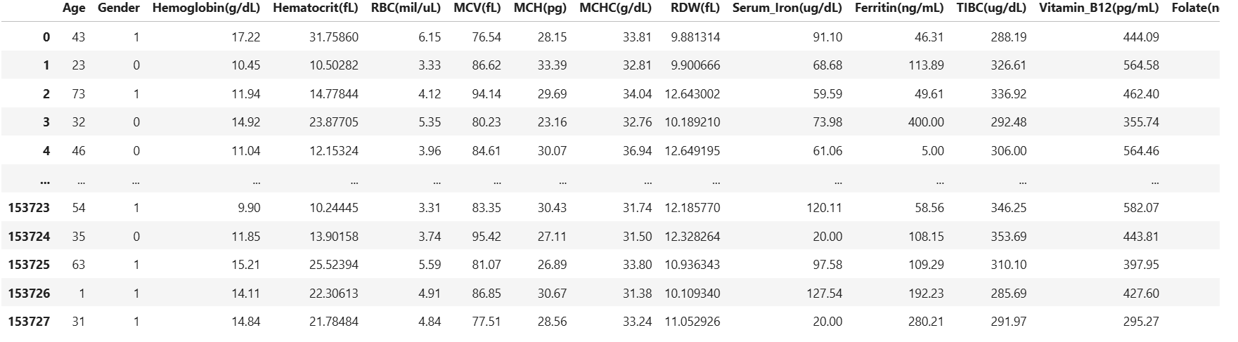

3.2 Feature Description
The dataset contains 17 independent features consisting of demographic information and hematological blood parameters routinely measured in clinical laboratory settings:
Feature | Unit | Normal Range | Clinical Significance
Age | Years | 1 – 90 | Demographic variable
Gender | 0/1 (F/M) | — | Demographic variable
Hemoglobin | g/dL | 12.0 – 18.0 | Primary anemia indicator
Hematocrit | fL | 36.0 – 50.0 | RBC volume fraction
RBC Count | mil/uL | 4.0 – 6.0 | Red blood cell count
MCV | fL | 80.0 – 100.0 | Mean corpuscular volume
MCH | pg | 27.0 – 33.0 | Mean corpuscular hemoglobin
MCHC | g/dL | 32.0 – 36.0 | Mean corpuscular Hb concentration
RDW | fL | 11.5 – 14.5 | Red cell distribution width
Serum Iron | ug/dL | 60.0 – 170.0 | Iron level in blood
Ferritin | ng/mL | 30.0 – 300.0 | Iron storage protein
TIBC | ug/dL | 250.0 – 400.0 | Total iron-binding capacity
Vitamin B12 | pg/mL | 200.0 – 900.0 | Cobalamin level
Folate | ng/mL | 2.7 – 17.0 | Folic acid level
CRP | mg/L | 0.0 – 5.0 | C-reactive protein (inflammation)
WBC | 10³/uL | 4.5 – 11.0 | White blood cell count
Platelets | 10³/uL | 150.0 – 400.0 | Platelet count

3.3 Descriptive Statistics
Key statistical summaries derived from data.describe() provide insight into feature distributions and value ranges:
Feature | Mean | Std Dev | Min | Max | Median
Age (years) | 34.74 | 17.49 | 1 | 90 | 35.00
Hemoglobin (g/dL) | 13.08 | 2.12 | 6.00 | 18.00 | 13.25
Hematocrit (fL) | 17.99 | 5.67 | 3.60 | 39.27 | 17.92
RBC (mil/uL) | 4.47 | 0.78 | 2.00 | 7.16 | 4.52
Serum Iron (ug/dL) | 83.92 | 31.11 | 20.00 | 200.00 | 83.97
Ferritin (ng/mL) | 118.50 | 69.34 | 5.00 | 400.00 | 116.87
TIBC (ug/dL) | 311.48 | 44.69 | 200.00 | 450.00 | 310.13

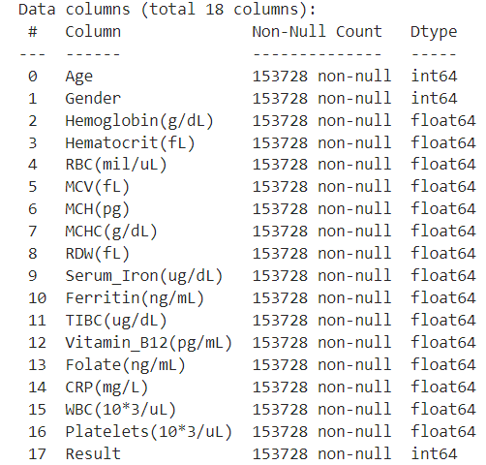

4. Exploratory Data Analysis

4.1 Target Variable Distribution
The dataset exhibits a moderate class imbalance between the two outcome categories:
- No Anemia (Class 0): 100,395 records — 65.3% of the dataset
- Anemia (Class 1): 53,333 records — 34.7% of the dataset
The approximately 2:1 ratio of non-anemic to anemic cases reflects realistic clinical prevalence. While not severely imbalanced, this distribution was considered during model evaluation, particularly in examining recall for the minority (anemic) class.

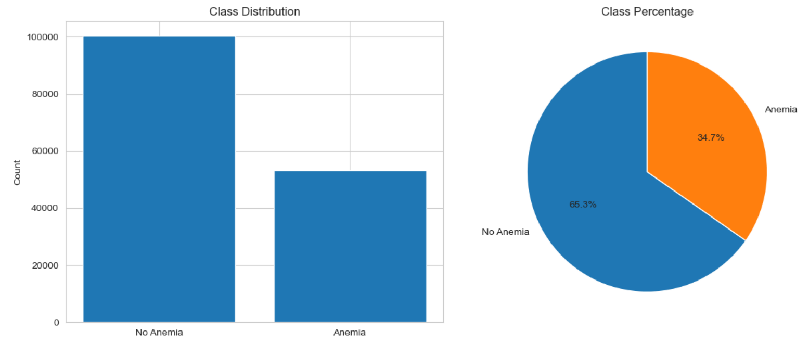

4.2 Gender Analysis
The dataset is nearly gender-balanced with 77,001 males (50.1%) and 76,727 females (49.9%). Anemia rates differ meaningfully by gender:
Gender | No Anemia Rate | Anemia Rate
Female (0) | 60.73% | 39.27%
Male (1) | 69.87% | 30.13%
Females exhibit a notably higher anemia prevalence (39.27% vs. 30.13%), consistent with clinical literature attributing this to menstrual blood loss and pregnancy-related iron demands.
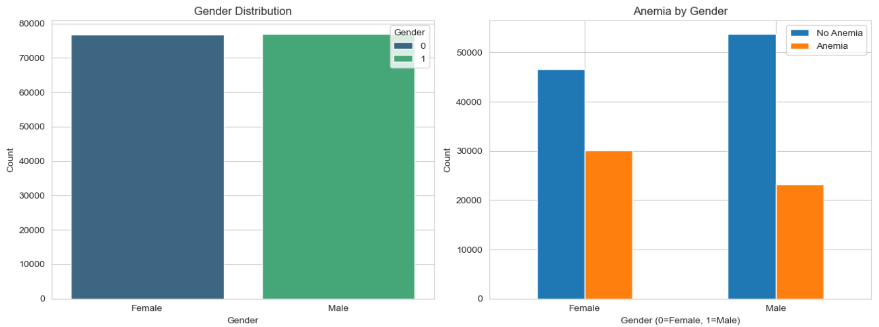

4.3 Age Distribution
Patient ages range from 1 to 90 years with a mean of 34.74 years and a median of 35 years, indicating a roughly symmetric distribution skewed slightly toward younger-to-middle-aged patients. The scatter plot analysis of age by anemia status shows no strong age-based differentiation, with both anemic and non-anemic patients distributed broadly across all age groups.
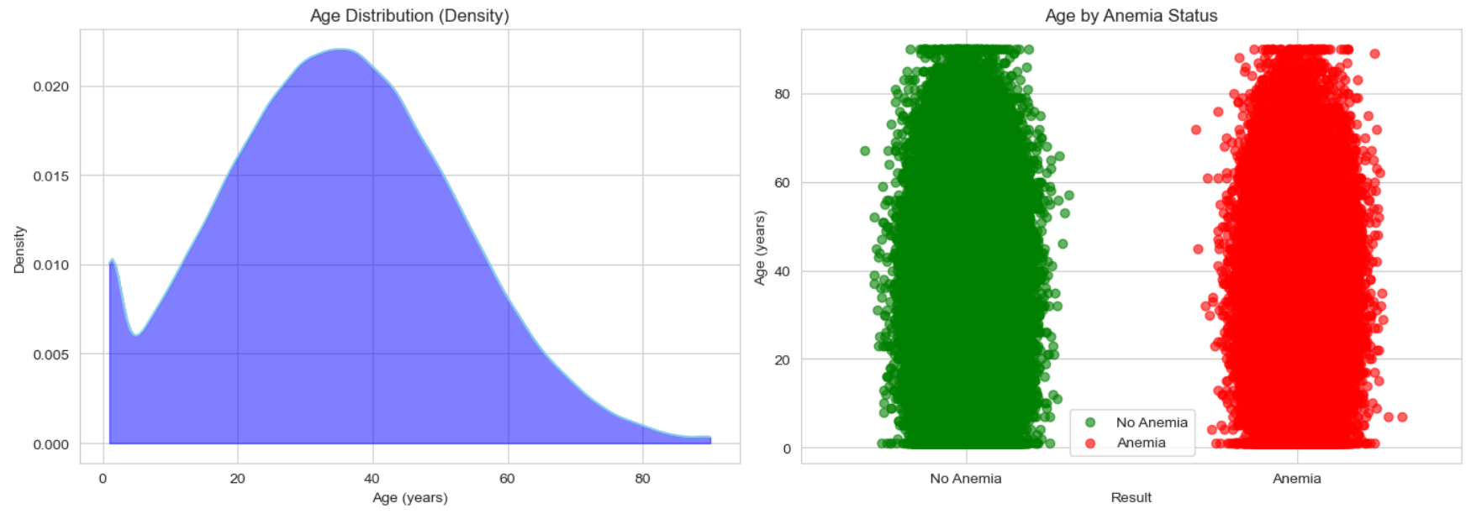

4.4 Feature Correlations with Anemia
Pearson correlation analysis with the target variable (Result) revealed the following key relationships:
Feature | Correlation | Interpretation
Hemoglobin (g/dL) | –0.775 | Strongest negative predictor
Hematocrit (fL) | –0.728 | Strong negative correlation
RBC (mil/uL) | –0.692 | Strong negative correlation
Serum Iron (ug/dL) | –0.269 | Moderate negative correlation
Ferritin (ng/mL) | –0.254 | Moderate negative correlation
TIBC (ug/dL) | +0.347 | Strongest positive predictor
RDW (fL) | +0.248 | Moderate positive correlation
Gender | –0.096 | Weak negative correlation

These correlations align well with established clinical knowledge: lower hemoglobin, hematocrit, and RBC values are hallmark indicators of anemia, while elevated TIBC reflects compensatory iron transport increase in iron-deficient states.

Correlation Values:
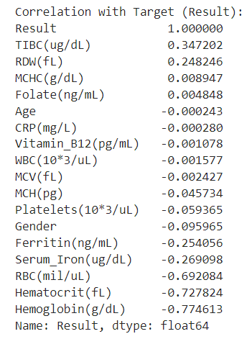
Coefficient Variation:
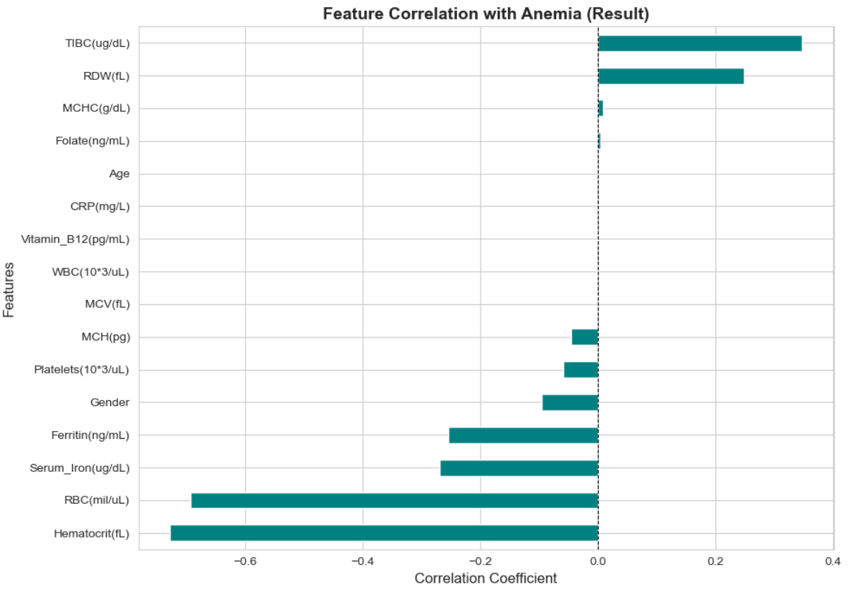

Correlation Matrix:

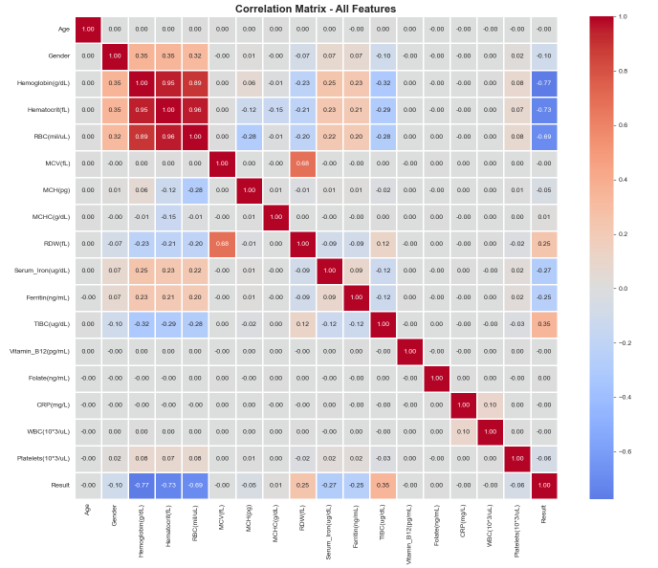

Blood Parameters Varying Anemia:

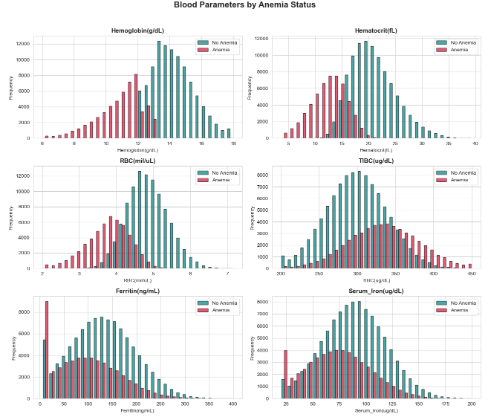

Pairplot for Selected Parameters:

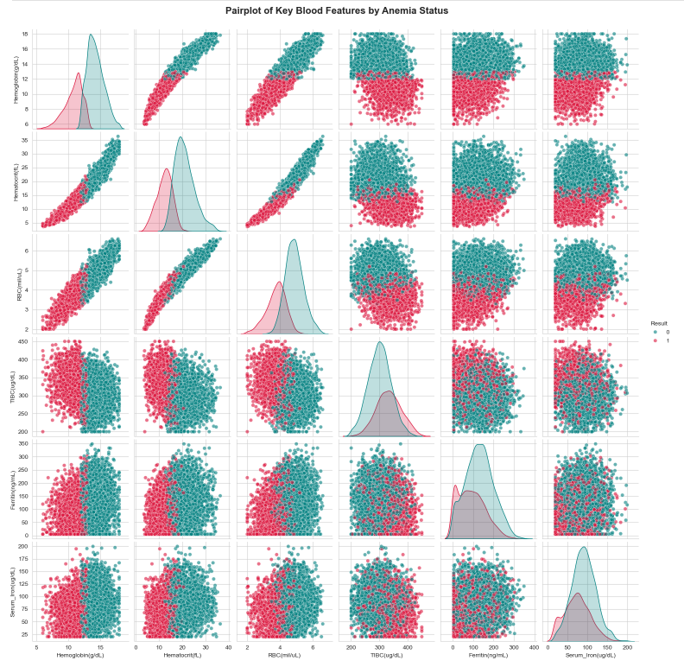

4.5 Outlier Analysis
IQR-based outlier detection was performed on all numeric features. The following features exhibited the highest outlier proportions:
Feature | Outlier Count | Percentage
CRP (mg/L) | 7,233 | 4.71%
MCH (pg) | 1,610 | 1.05%
Hemoglobin (g/dL) | 1,508 | 0.98%
RBC (mil/uL) | 1,377 | 0.90%
RDW (fL) | 1,275 | 0.83%
CRP showed the highest outlier rate (4.71%), likely reflecting patients with acute inflammatory conditions. The overall outlier proportion across features was low (under 5%), suggesting the dataset is relatively clean. No outlier removal was performed, as these values may represent clinically valid extreme cases.
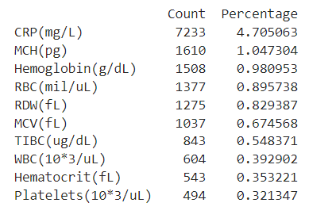

5. Feature Selection & Preprocessing

5.1 Selected Features
Based on clinical relevance and correlation analysis, 14 blood parameters were selected as model input features, excluding Age, Gender, and CRP which showed negligible linear correlations with the target:
Selected Features (14 Total) | Rationale
Hemoglobin, Hematocrit, RBC | Primary CBC anemia markers (highest correlation)
Serum Iron, Ferritin, TIBC | Iron metabolism indicators
MCV, MCH, MCHC, RDW | Red cell morphology parameters
WBC, Platelets | Broader blood panel context
Vitamin B12, Folate | Nutritional deficiency markers

5.2 Data Splitting
The dataset was partitioned using a stratified train-test split to preserve the class distribution across both subsets:
- Training Set: 80% — 122,982 records
- Test Set: 20% — 30,746 records
- Random State: 42 (for reproducibility)
- Stratify: Yes (maintains anemia/non-anemia ratio)

5.3 Feature Scaling
StandardScaler from scikit-learn was applied to normalize all 14 features to zero mean and unit variance. The scaler was fit exclusively on the training set and applied to both training and test sets to prevent data leakage. The fitted scaler was serialized as scaler.pkl for reuse in the prediction application.

6. Model Implementation

6.1 Random Forest Classifier

Random Forest is an ensemble learning method that constructs multiple decision trees during training and outputs the mode of their individual predictions. It is robust to overfitting due to bootstrap aggregation (bagging) and random feature selection at each split.
Hyperparameter | Value
n_estimators | 100
random_state | 42
n_jobs | -1 (all cores)
max_features | sqrt (default)
Training Time | 7.08 seconds

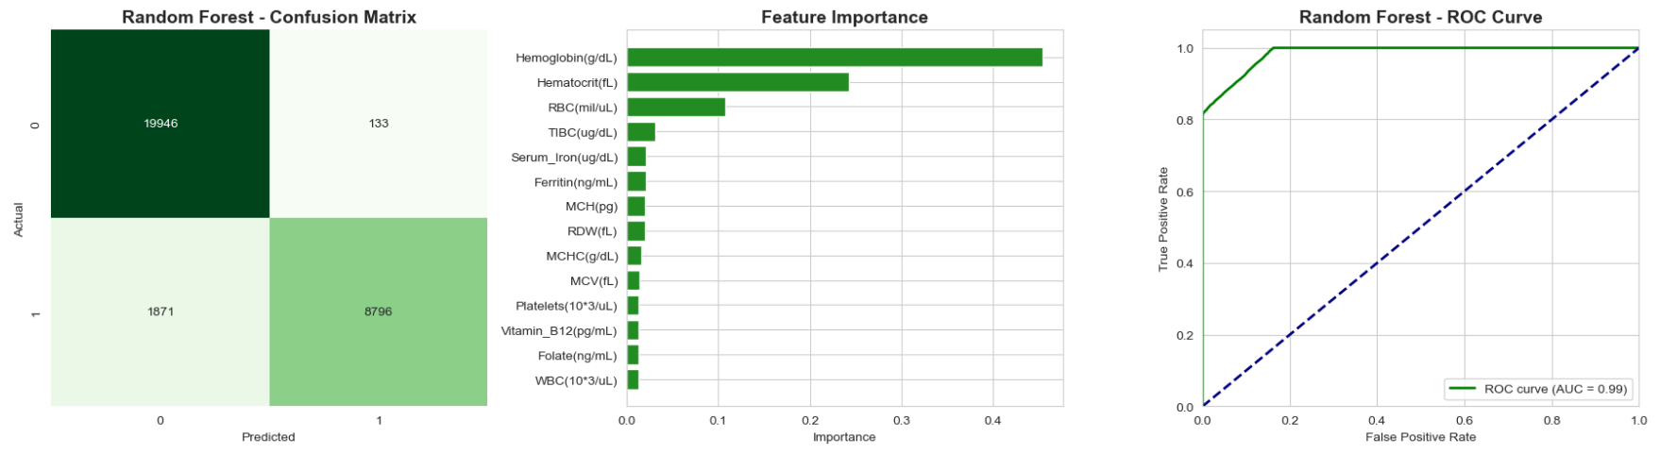

6.2 XGBoost Classifier
XGBoost (Extreme Gradient Boosting) is a scalable gradient boosting framework that builds trees sequentially, with each tree correcting errors of the previous. It is known for high performance and computational efficiency.
Hyperparameter | Value
random_state | 42
eval_metric | logloss
n_estimators | 100 (default)
learning_rate | 0.3 (default)
Training Time | 1.02 seconds
XGBoost trained approximately 7x faster than Random Forest (1.02s vs. 7.08s), demonstrating its computational efficiency advantage on large datasets.

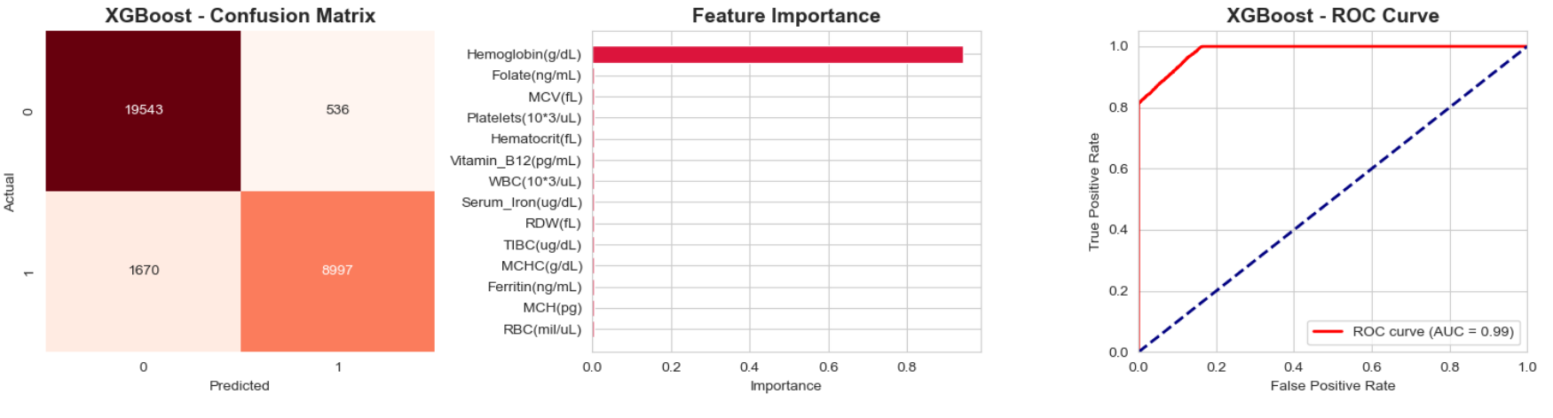

6.3 Ensemble Prediction Strategy
The Streamlit application implements a simple majority voting ensemble: if at least one of the two models predicts anemia, the ensemble result is flagged as anemia. The confidence score is calculated as the average of both models' maximum class probability. This conservative approach minimizes false negatives, which is clinically preferable — it is safer to over-refer than to miss a true anemia case.

7. Model Evaluation & Results

7.1 Performance Metrics
Both models were evaluated on the held-out test set (30,746 records) using four standard classification metrics:
Model | Accuracy | Precision | Recall | F1-Score
Random Forest | 93.48% | 98.51% | 82.46% | 89.77%
XGBoost | 92.83% | 94.38% | 84.34% | 89.08%
Random Forest outperformed XGBoost on Accuracy, Precision, and F1-Score, making it the best overall model for this task. XGBoost achieved a marginally higher recall (84.34% vs. 82.46%), indicating it correctly identified slightly more true anemia cases at the cost of more false positives.
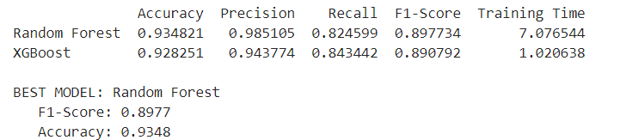

7.2 Metric Interpretation
Metric | Random Forest | XGBoost
Accuracy | 93.48% — correctly classifies 28,748 of 30,746 cases | 92.83% — correctly classifies 28,548 of 30,746 cases
Precision | 98.51% — when RF predicts anemia, it is correct 98.5% of the time | 94.38% — slightly more false positives than RF
Recall | 82.46% — detects 82.5% of all actual anemia cases | 84.34% — detects slightly more anemia cases
F1-Score | 89.77% — best harmonic balance of precision and recall | 89.08% — slightly lower balance

7.3 Feature Importance
Random Forest's built-in feature importance (mean decrease in impurity) highlighted the following top predictors:
- Hemoglobin (g/dL) — consistently the highest-importance feature, reflecting its direct role in anemia diagnosis.
- Hematocrit (fL) — second most important, closely related to hemoglobin.
- RBC Count (mil/uL) — third most important, directly measuring red cell abundance.
- TIBC (ug/dL) — fourth, reflecting iron transport capacity elevation in deficiency states.
- Serum Iron and Ferritin — mid-range importance, contributing supplementary diagnostic signals.
Features such as WBC, Vitamin B12, CRP, and Folate showed lower importance scores, suggesting limited discriminative power for binary anemia classification in this dataset. This is consistent with these markers being more relevant for specific anemia subtypes.

7.4 Best Model Conclusion
Random Forest is selected as the primary production model due to its superior precision (98.51%) and F1-Score (89.77%). Its extremely high precision is particularly valuable in a clinical support context — when the model raises an anemia flag, there is very high confidence in the prediction. The ensemble approach in the application combines both models to leverage XGBoost's marginally better recall as a safety net.

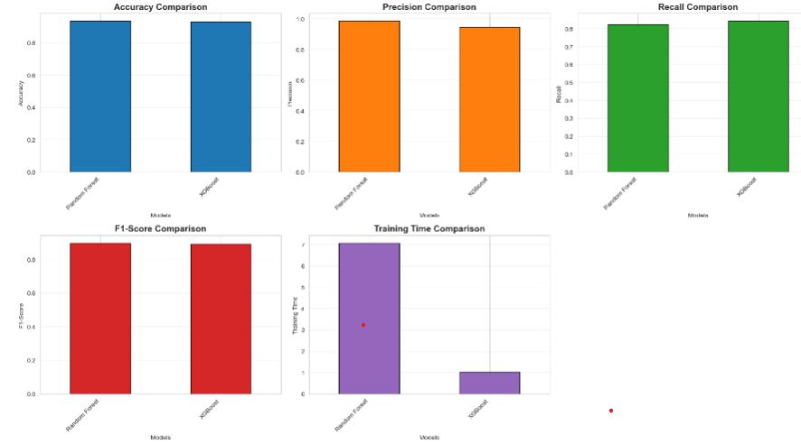
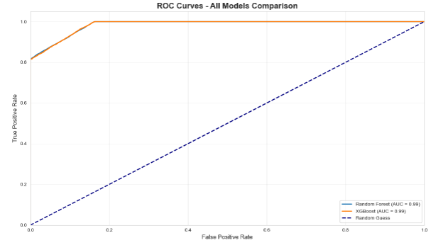

8. Streamlit Web Application

8.1 Overview
A production-grade interactive prediction application was built using Streamlit. The app allows clinicians or analysts to input patient blood parameters via intuitive sliders and receive instant anemia predictions from both models along with an ensemble decision.

8.2 Application Architecture
- Frontend: Streamlit with custom CSS styling (Inter font, dark-mode palette, teal/red color scheme)
- Backend: Pre-trained Random Forest and XGBoost models loaded from serialized .pkl files via joblib
- Preprocessing: The same StandardScaler used during training is loaded and applied to user input
- Prediction: Both models predict independently; ensemble vote determines the final result
- Visualization: Matplotlib charts embedded for real-time confidence and feature importance display

Anemia Detected:

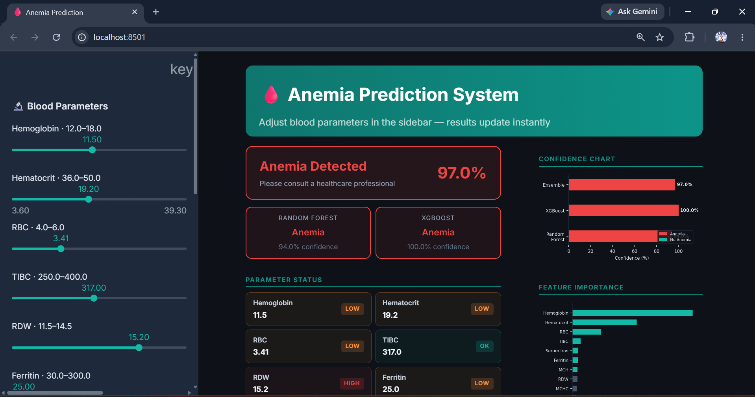

No Anemia Detected:

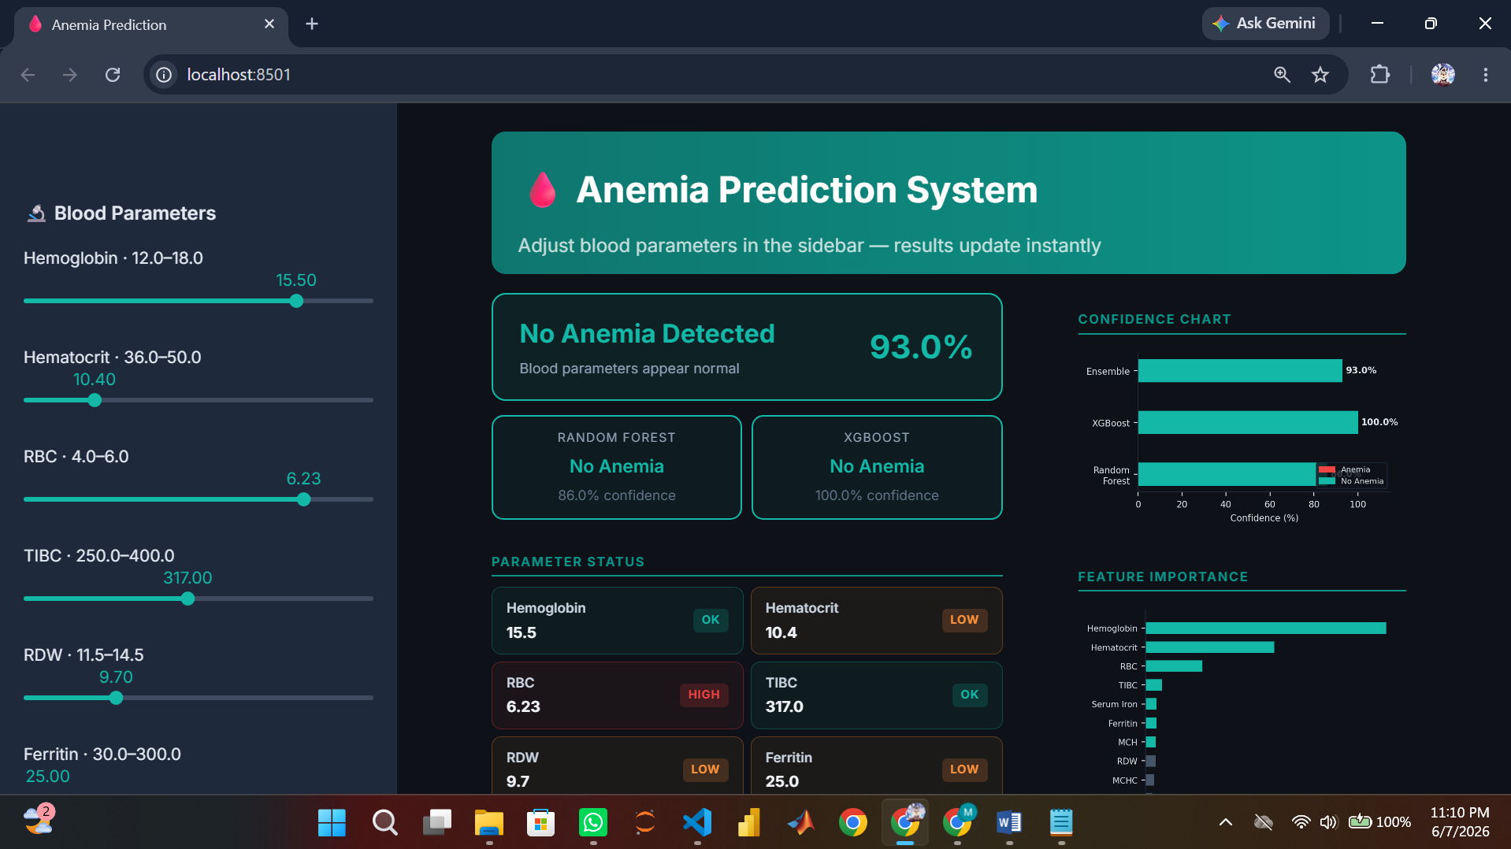

8.3 Key Features
Feature | Description
Real-time Prediction | Results update instantly as sliders are adjusted — no submit button required
Parameter Status Grid | Each of 14 blood parameters displays a color-coded badge (OK / Low / High) based on clinical reference ranges
Dual Model Display | Individual predictions from Random Forest and XGBoost shown side-by-side with confidence %
Ensemble Decision Banner | A prominent result banner (red for Anemia, teal for No Anemia) with overall confidence score
Confidence Chart | Horizontal bar chart showing prediction confidence for all three models (RF, XGBoost, Ensemble)
Feature Importance Chart | Bar chart of RF feature importances, color-coded by above/below median importance
Healthy Range Display | Slider labels show normal reference ranges for each parameter

8.4 Model Loading & Serialization
Models are cached using @st.cache_resource to avoid reloading on every user interaction. Three files are required at runtime:
- rf_model.pkl — Trained Random Forest classifier
- xgb_model.pkl — Trained XGBoost classifier
- scaler.pkl — Fitted StandardScaler for input normalization
All three files are generated at the end of the training notebook using joblib.dump() and must be co-located with the app.py file at runtime.

9. Limitations & Future Work

9.1 Current Limitations
- Binary Classification Only: The system classifies patients as anemic or non-anemic but does not differentiate between anemia subtypes (iron-deficiency, megaloblastic, aplastic, hemolytic, etc.), which require different treatments.
- Class Imbalance: The 65:35 class ratio may marginally bias the model toward predicting the majority class. Techniques such as SMOTE or class weighting were not applied in this iteration.
- No Hyperparameter Tuning: Both models were trained with default or lightly specified hyperparameters. Grid search or Bayesian optimization could yield improved performance.
- Limited Demographic Features: Age and Gender were excluded from the final feature set due to low correlation. More complex interactions (e.g., age-stratified hemoglobin thresholds) are not captured.
- No Cross-Validation: A single train-test split was used. K-fold cross-validation would provide more robust performance estimates and reduce the effect of random variation in the split.
- Single Dataset: Generalizability to other patient populations or laboratory instruments has not been validated. External validation on a different cohort is recommended before clinical deployment.

9.2 Future Improvements
- Anemia Subtype Classification: Extend to multi-class classification for iron-deficiency, B12 deficiency, folate deficiency, and other subtypes using the same feature set with additional markers.
- Hyperparameter Optimization: Implement RandomizedSearchCV or Optuna for automated hyperparameter tuning to potentially improve F1-score and recall.
- Imbalance Handling: Apply SMOTE (Synthetic Minority Oversampling Technique) or adjust class weights to improve recall on the minority anemia class.
- Additional Models: Evaluate LightGBM, CatBoost, and neural network architectures (e.g., TabNet) as alternative classifiers.
- SHAP Explainability: Integrate SHAP (SHapley Additive exPlanations) values into the application to provide patient-level feature contribution explanations for clinician transparency.
- Longitudinal Analysis: Incorporate time-series patient data to model anemia progression and treatment response over time.
- API Deployment: Expose the prediction model as a REST API using FastAPI or Flask for integration with existing hospital information systems (HIS).

10. Conclusion
This project successfully demonstrates the application of machine learning to clinical anemia prediction using a large-scale hematological dataset. The analysis pipeline — from data exploration through model deployment — provides a complete framework for building automated clinical decision support tools.
The Random Forest classifier achieved the best overall performance with 93.48% accuracy and an F1-Score of 89.77%, supported by a precision of 98.51% that makes it highly reliable in flagging true anemia cases. The XGBoost model offers a complementary trade-off with marginally higher recall, and the ensemble approach in the web application leverages both models for balanced clinical decision support.
Key clinical insights confirmed by the data analysis include the primacy of Hemoglobin, Hematocrit, and RBC count as anemia predictors, the gender disparity in anemia prevalence, and the diagnostic utility of iron metabolism markers (Serum Iron, Ferritin, TIBC). These findings align with established hematological knowledge, validating the dataset quality and analytical methodology.
The Streamlit application provides an accessible, real-time interface for prediction, making the model practically useful in a screening or educational context. With further validation, hyperparameter optimization, and subtype classification capabilities, this system has strong potential for deployment in clinical laboratory workflows.

Achievement | Value
Dataset Processed | 153,728 patient records
Features Engineered | 14 hematological parameters
Best Model Accuracy | 93.48% (Random Forest)
Best F1-Score | 89.77% (Random Forest)
Best Precision | 98.51% (Random Forest)
Application Built | Streamlit real-time prediction app

